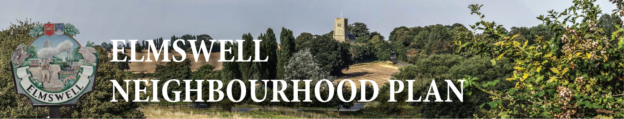

MINUTES OF A STEERING GROUP MEETING
held on Thursday 22nd January 2015
at The Blackbourne
Present: Members; Marian Abbott, Julie Cole, Peter Dow, Peter Edmonds, Terry Garner,
Peter Goodridge, Sarah Mansel (Ch.), Fred Pallett, Shaun Pratt, Ann Richards.
Visiting; Robert Horn of CAS
1 Apologies were noted from Philip Blissett and from Mary Feeney
2 The Minutes of the last meeting, held on 13th November, were accepted as a true
record.
3 There were no matters arising from the Minutes and not dealt with as an Agenda item.
4 Reports were received and comments noted from consultations held with the following
community groups: Art Group, Baby & Toddler Group, Christians together, FRESCH,
Ladies Lunch group, WI (evening group), Youth organisations.
4.1 Arrangements were confirmed or other action determined re meeting with: Health
Centre, History Group, WI afternoon group, carpet bowls club, Fire & Police
services.
5 Minor modifications to text, content, and layout of questionnaires in light of feedback from
community groups were agreed. Peter D agreed to incorporate these into the master
copies to also include the ‘preamble’, as previously drafted, with a strong emphasis added
re encouraging ‘on-line’ responses & offers of help to do this.
6 The following way forward re questionnaires was agreed:
6.1 Peter D to organise liaison between Robert Horn & printers towards a draft of the
documents in publishable format;
6.2 Aiming for distribution via Newsletter volunteers 6th March;
6.3 Marian & Julie to liaise with Elmswell School towards distribution / completion in
school immediately prior to 6th March;
6.4 Peter D to formalise an arrangement with Thurston School as previously discussed
with them;
6.5 Peter D & Peter Ed to distribute business questionnaires.
7 Peter D outlined some of the elements of the baseline data element of the Plan, as
confirmed at a meeting earlier in the day with Peter freer & Jonathan Free at MSDC. He
undertook to copy to members 2 examples of such documentation from elsewhere and to
produce a schedule of issues which might be addressed in Elmswell’s Plan for debate.
8 There was no other business raised for discussion, to be noted or for inclusion on a future
agenda
9 The date of the next meeting was agreed as Tuesday 17th February at 7.30.
10 The meeting closed at 9.15.
Peter Dow
23.01.15

